|  |  |  |
| --- | --- | --- |
| Name | Date of Birth | Age |
| Bernante Pedro | 4/12/1956 | 63(S) |
| Bernante Corazon | 5/2/1958 | 61(S)S |
| Bernante Tersonald | 3/26/1980 | 39 |
| Bernante Marricar | 9/4/1981 | 38 |
| Bernante Sebastian Jieo | 3/25/2014 | 5 |
| C:\Users\admin\Documents\PONGASI\IMG_20191124_072136 - Copy.jpg | 4ps Member | House Material |
| No | Concrete |
| Water Source | Type of Toilet |
| Pipe | Water Sealed |

|  |  |  |
| --- | --- | --- |
| Name | Date of Birth | Age |
| Salcedo, Benhur Seno | 7/23/1972 | 47 |
| Salcedo, Lyn Silanga | 5/19/1972 | 47 |
| Salcedo, Nyl Rhunib Silanga | 5/6/2008 | 11 |
| Salcedo, Krecia Lei Silanga | 4/9/2006 | 13 |
| C:\Users\admin\Documents\PONGASI\IMG_20191124_072059.jpg | 4ps Member | House Material |
| No | Concrete |
| Water Source | Type of Toilet |
| Pipe | Water Sealed |

|  |  |  |
| --- | --- | --- |
| Name | Date of Birth | Age |
| Panes, Jade Balios | 6/29/1979 | 40 |
| Panes, Jeneliza Albios | 10/19/1974 | 45 |
| Panes, Althea Kristile Albios | 11/5/2008 | 11 |
| Panes, Alexa Kysha Albios | 10/25/2010 | 9 |
|  | 4ps Member | House Material |
| No | Concrete |
| Water Source | Type of Toilet |
| Pipe | Water Sealed |

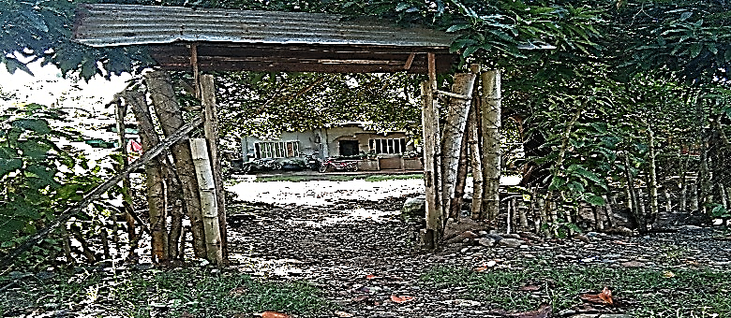

|  |  |  |
| --- | --- | --- |
| Name | Date of Birth | Age |
| Tac-an, Diego Buhian | 8/4/ 1960 | 59 |
| Tac-an, Cresencia Baugbug | 6/15/1957 | 62 (S) |
| Tac-an, Gleen, Baugbug | 8/21/1990 | 29 |
| Tac-an, Jerald Baugbug | 8/25/1992 | 27 |
|  | 4ps Member | House Material |
| No | Concrete |
| Water Source | Type of Toilet |
| Pipe | Water Sealed |

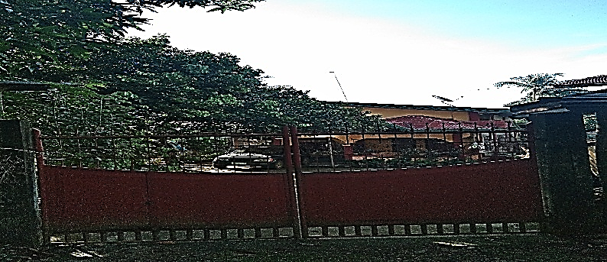

|  |  |  |
| --- | --- | --- |
| Name | Date of Birth | Age |
| Villegas, Carlos Chan | 5/13/1939 | 80 (S) |
| Villegas, Guadalupe Baugbug | 12/12/1921 | 98(S) |
|  | 4ps Member | House Material |
| No | Semi-Concrete |
| Water Source | Type of Toilet |
| Pipe | Water Sealed |

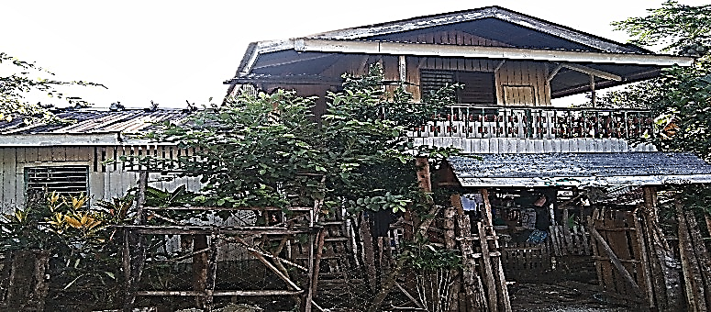

|  |  |  |
| --- | --- | --- |
| Name | Date of Birth | Age |
| Aljas, Clemente Ansing | 12/5/1949 | 70 (S) |
| Balili, Ian Aljas | 2/21/1997 | 22 |
|  | 4ps Member | House Material |
| No | Concrete |
| Water Source | Type of Toilet |
| Pipe | Water Sealed |

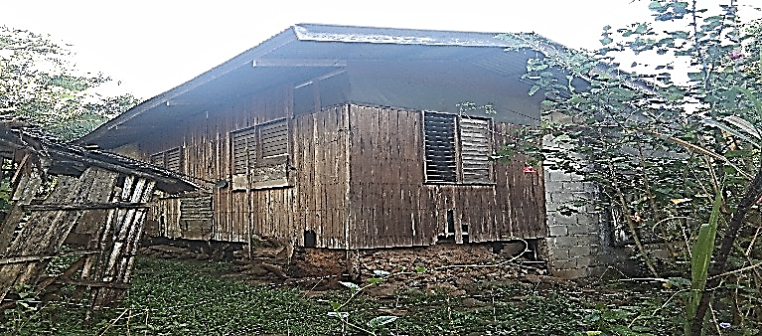

|  |  |  |
| --- | --- | --- |
| Name | Date of Birth | Age |
| Garcia, Ramuel Pugay | 5/1/1958 | 61 (S) |
| Garcia, Mayfe Pugay | 10/10/1981 | 39 |
| Garcia, Jefferson Pugay | 4/9/2000 | 19 |
| Garcia , Elealyn Pugay | 8/2/2008 | 11 |
| Garcia, Loraine Machree | 9/30/1991 | 28 |
| Garcia, Ramuel Pasturan | 2/19/1993 | 25 |
| C:\Users\admin\Documents\PONGASI\IMG_20191124_072401 - Copy.jpg | 4ps Member | House Material |
| No | Concrete |
| Water Source | Type of Toilet |
| Pipe | Water Sealed |

|  |  |  |
| --- | --- | --- |
| Name | Date of Birth | Age |
| Cobar, Junjie Nobleza | 12/2/1983 | 36 |
| Cobar, Melisa Pugoy | 5/27/1986 | 33 |
| Cobar, Jeveliza Mae | 5/15/2006 | 13 |
| Cobar, Joshua Zachary | 9/6/2014 | 5 |
| C:\Users\admin\Documents\PONGASI\IMG_20191124_071829.jpg | 4ps Member | House Material |
| No | Wood |
| Water Source | Type of Toilet |
| Pipe | Water Sealed |

|  |  |  |
| --- | --- | --- |
| Name | Date of Birth | Age |
| Lascona, Gregorio Alicos | 5/20/1960 | 59 |
| Lascona, Vivian Ortiz | 12/2/1968 | 51 |
| Lascona, Mark Greggy Ortiz | 10/5/1988 | 31 |
| Lascona, Marlineta Frias | 10/6/1995 | 24 |
| Lascona, Shaina Grace Frias | 10/8/2014 | 5 |
| Lascona, Shantal Mae Frias | 4/24/2017 | 2 |
| C:\Users\admin\Documents\PONGASI\IMG_20191124_071705 - Copy.jpg | 4ps Member | House Material |
| Yes | Wood |
| Water Source | Type of Toilet |
| Pipe | Water Sealed |

|  |  |  |
| --- | --- | --- |
| Name | Date of Birth | Age |
| Talan, Clifford Pamplona | 5/17/1985 | 34 |
| Talan, Roena Aya-ay | 7/21/1991 | 28 |
| Talan, Clirwen Jazz Aya-ay | 7/18/2010 | 9 |
| C:\Users\admin\Documents\PONGASI\IMG_20191124_071616.jpg | 4ps Member | House Material |
| No | Wood |
| Water Source | Type of Toilet |
| Pipe | Water Sealed |

|  |  |  |
| --- | --- | --- |
| Name | Date of Birth | Age |
| Lusica, Eleuterio Simogan | 6/21/1993 | 26 |
| Lusica, Jeraldine Lamparas | 6/20/1992 | 27 |
| Lusica, Jefferson Lamparas | 7/31/2008 | 11 |
| Lusica , Jay –R Lamparas | 9/28/2014 | 5 |
| Lusica, Justine, Lamparas | 11/23/2018 | 1 |
| Buoraga, Sophian Lamparas | 8/14/2007 | 12 |
| Mejares, Caridad Lamparas | 8/1/1948 | 71 (S) |
|  | 4ps Member | House Material |
| Yes | Concrete |
| Water Source | Type of Toilet |
| Pipe | Water Sealed |

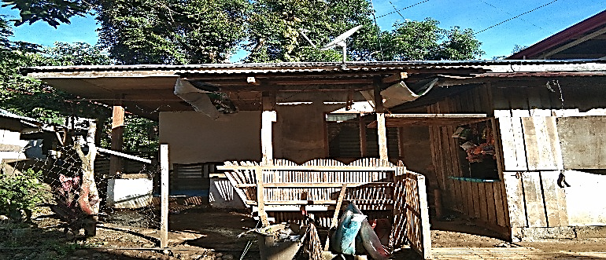

|  |  |  |
| --- | --- | --- |
| Name | Date of Birth | Age |
| Lamparas, Marites Combestra | 2/23/1973 | 46 |
| Lamparas, Reymark Combestra | 10/1/2005 | 14 |
| Hasan, Maireen Combestra | 12/11/1995 | 24 |
| Hasan, Mhaab Combestra | 5/14/2014 | 5 |
|  | 4ps Member | House Material |
| Yes | Concrete |
| Water Source | Type of Toilet |
| Pipe | Water Sealed |

|  |  |  |
| --- | --- | --- |
| Name | Date of Birth | Age |
| Tingholo, Sebiano Pongasi | 10/25/1979 | 40 |
| Tingholo, Roasalie Catigbe | 5/6/1980 | 39 |
| Tingholo, John Philip Catigbe | 2/19/2009 | 10 |
| Tingholo, John Ben David Catigbe | 2/21/2012 | 7 |
| Tingholo, Jillian Larisse Catigbe | 3/19/2016 | 3 |
| Tingholo, Rosalinda Pongasi | 3/24/1952 | 67(S) |
| Tingholo, Sebiano Pongasi | 10/25/1979 | 40 |
| C:\Users\admin\Documents\PONGASI\IMG_20191124_072513.jpg | 4ps Member | House Material |
| No | Concrete |
| Water Source | Type of Toilet |
| Pipe | Water Sealed |

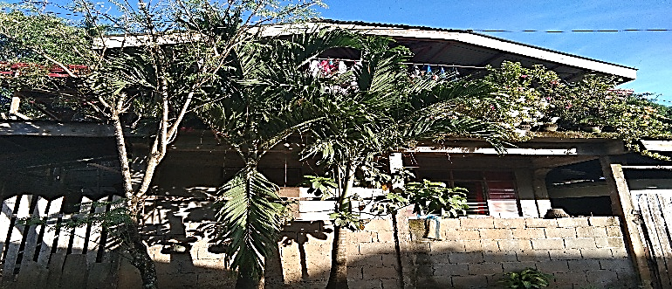

|  |  |  |
| --- | --- | --- |
| Name | Date of Birth | Age |
| Codia, Kim Canolo | 2/9/1974 | 45 |
| Codia, Rosalina Pongasi | 4/8/1976 | 43 |
| Codia, Christian Kim Pongasi | 3/25/2003 | 16 |
| Codia, Christine Rose Pongasi | 3/6/2004 | 17 |
| Tingholo, Jovita Talitayan | 2/14/1960 | 59 |
|  | 4ps Member | House Material |
| No | Concrete |
| Water Source | Type of Toilet |
| Pipe | Water Sealed |

|  |  |  |
| --- | --- | --- |
| Albuio  Name | Date of Birth | Age |
| Odin, Abdullahziz Cola | 11/15/1966 | 53 |
| Odin, Arlyn Albios | 11/10/1979 | 40 |
| Odin, Nadzma Albios | 2/18/2002 | 17 |
| Odin, Noaim Albios | 2/11/2003 | 16 |
| Odin, Nehan Albios | 4/22/2008 | 11 |
| C:\Users\admin\Documents\PONGASI\IMG_20191124_064430.jpgOdin, Nojaim Albios | 4/21/2015 | 4 |
|  | 4ps Member | House Material |
| Yes | Semi-Concrete |
| Water Source | Type of Toilet |
| Pipe | Water Sealed |

|  |  |  |
| --- | --- | --- |
| Name | Date of Birth | Age |
| Ramirez, Sonita Reguya | 9/20/1969 | 50 |
| C:\Users\admin\Documents\PONGASI\IMG_20191124_064511.jpg | 4ps Member | House Material |
| No | Concrete |
| Water Source | Type of Toilet |
| Pipe | Water Sealed |

|  |  |  |
| --- | --- | --- |
| Name | Date of Birth | Age |
| Tala, Elmo Miano | 9/23/1973 | 46 |
| Tala, Eden |  |  |
| Tala, Stephanie Lyn |  |  |
| C:\Users\admin\Documents\PONGASI\IMG_20191124_064601.jpg | 4ps Member | House Material |
| No | Concrete |
| Water Source | Type of Toilet |
| Pipe | Water Sealed |

|  |  |  |
| --- | --- | --- |
| Name | Date of Birth | Age |
| Tala, Paquito Solatorio | 6/4/1938 | 81(S) |
| Tala, Santas Miano | 12/20/1938 | 81(S) |
|  |  |  |
|  |  |  |
|  |  |  |
| C:\Users\admin\Documents\PONGASI\IMG_20191124_064617.jpg | 4ps Member | House Material |
| No | Concrete |
| Water Source | Type of Toilet |
| Pipe | Water Sealed |

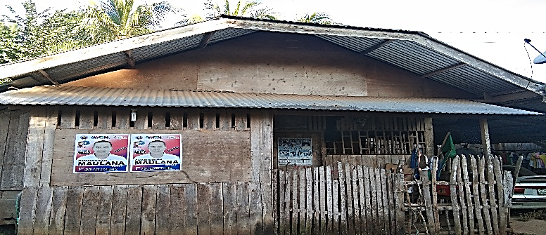

|  |  |  |
| --- | --- | --- |
| Name | Date of Birth | Age |
| Villasan, Sopronio Lahoy | 3/11/1951 | 68(S) |
| Villasan, Jhonalyn Lahoy | 10/18/1978 | 41 |
| Villasan, Jonaven Lahoy | 12/1/1992 | 27 |
| Palma, Carla Danielle | 7/16/2012 | 7 |
|  | 4ps Member | House Material |
| No | Semi-Concrete |
| Water Source | Type of Toilet |
| Pipe | Water Sealed |

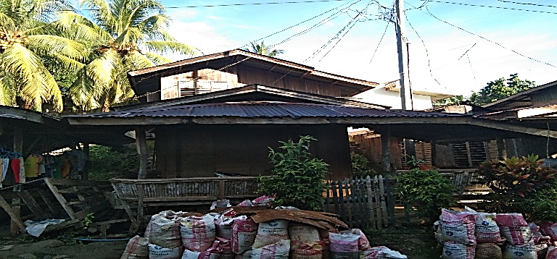

|  |  |  |
| --- | --- | --- |
| Name | Date of Birth | Age |
| Butito, Juanita Campomanes | 10/21/1960 | 59 |
| Campomanes, Lorita Pugoy | 2/11/1974 | 45 |
| Pajardo, Tonivern Campomanes | 1/30/2003 | 16 |
|  | 4ps Member | House Material |
| No | Wood |
| Water Source | Type of Toilet |
| Pipe | Water Sealed |

|  |  |  |
| --- | --- | --- |
| Name | Date of Birth | Age |
| Viña, Charlie | 5/12/1964 | 55 |
| Viña, Luisa Balajula | 6/21/1955 | 64(S) |
| Viña, Charles Louie | 5/31/2004 | 5 |
| C:\Users\admin\Documents\PONGASI\IMG_20191124_065341 - Copy.jpg | 4ps Member | House Material |
| No | Wood |
| Water Source | Type of Toilet |
| Pipe | Water Sealed |

|  |  |  |
| --- | --- | --- |
| Name | Date of Birth | Age |
| Bagarinao, Adolfo Bayla Sr. | 9/27/1960 | 59 |
| Bagarinao, Daisy Juano | 12/7/1964 | 55 |
| Bagarinao, Adolfo Juano Jr. | 9/20/1994 | 25 |
| C:\Users\admin\Documents\PONGASI\IMG_20191124_065049.jpg | 4ps Member | House Material |
| No | Wood |
| Water Source | Type of Toilet |
| Pipe | Water Sealed |

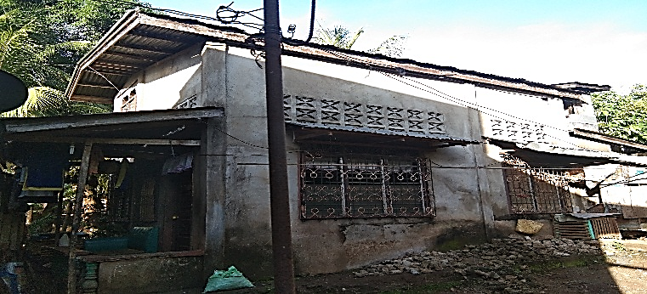

|  |  |  |
| --- | --- | --- |
| Name | Date of Birth | Age |
| Pajota, Jerry Albios Sr. | 7/3/1972 | 47 |
| Pajota, Ellen Butito | 3/8/1977 | 42 |
| Pajota, Jerry Butito Jr. | 3/5/2001 | 18 |
| Pajota, Jier Allen Butito | 10/10/2004 | 15 |
| Pajota, Jazzriel Butito | 10/9/2009 | 10 |
| Pajota, Justine Butito | 7/26/2011 | 8 |
| Pajota, Jazzper Butito | 3/31/2014 | 5 |
|  | 4ps Member | House Material |
| Yes | Wood |
| Water Source | Type of Toilet |
| Pipe | Water Sealed |

|  |  |  |
| --- | --- | --- |
| Name | Date of Birth | Age |
| Solatorio, Gorgonio Campomanes | 9/9/1960 | 59 |
| Solatorio, Susan Abadies | 12/31/1965 | 54 |
| Lumayag, Manny Herebesi | 8/22/1984 | 35 |
| Lumayag, Raquel Solatorio | 9/8/1987 | 32 |
| Lumayag, Marny Carl Solatorio | 7/16/2017 | 2 |
| Patrocenio, Ednalyn Saluania | 8/20/1995 | 24 |
| C:\Users\admin\Documents\PONGASI\IMG_20191124_064923.jpg | 4ps Member | House Material |
| No | Concrete |
| Water Source | Type of Toilet |
| Pipe | Water Sealed |

|  |  |  |
| --- | --- | --- |
| Name | Date of Birth | Age |
| Pajota, Venerando Albios | 11/9/1966 | 53 |
| Pajota, Rosie Suan | 11/11/1978 | 41 |
| Pajota , Venny Rose Regadio | 5/31/1997 | 21 |
| Pajota Ariel Regadio | 10/3/1998 | 20 |
| Pajota, Diether Regadio | 12/3/2001 | 18 |
| Pajota, Vincent John Regadio | 12/5/2006 | 13 |
| Pajota, JUndie Regadio | 10/16/2008 | 11 |
| Pajota, Dave Andrew Regadio | 2/19/2015 | 4 |
| Pajota, Vhea Rose | 6/14/2016 | 3 |
|  | 4ps Member | House Material |
| Yes | Wood |
| Water Source | Type of Toilet |
| Pipe | Water Sealed |

|  |  |  |
| --- | --- | --- |
| Name | Date of Birth | Age |
| Solatorio,Maria Granada | 10/22/1936 | 83(S) |
| C:\Users\admin\Documents\PONGASI\IMG_20191124_064840.jpg | 4ps Member | House Material |
| No | Wood |
| Water Source | Type of Toilet |
| Pipe | Water Sealed |

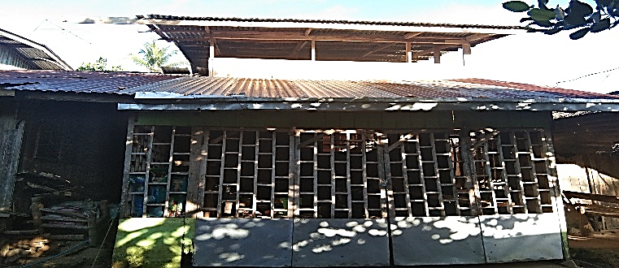

|  |  |  |
| --- | --- | --- |
| Name | Date of Birth | Age |
| Abubo, Abito Asoy | 2/5/1963 | 56 |
| Abubo, Albert Albios | 5/17/1984 | 35 |
| Abubo, Nikkie Rose Wenceslao | 5/18/1982 | 37 |
|  | 4ps Member | House Material |
| No | Concrete |
| Water Source | Type of Toilet |
| Pipe | Water Sealed |

|  |  |  |
| --- | --- | --- |
| Name | Date of Birth | Age |
| Balnig, Carmelita Lanticse | 3/11/1951 | 68(S) |
| Wahing, Clifford Balnig | 5/10/1992 | 27 |
| C:\Users\admin\Documents\PONGASI\IMG_20191124_065417 - Copy - Copy (2) - Copy.jpg | 4ps Member | House Material |
| No | Wood |
| Water Source | Type of Toilet |
| Pipe | Water Sealed |

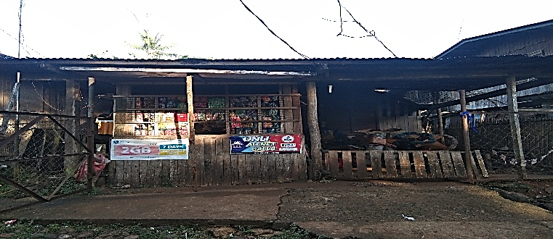

|  |  |  |
| --- | --- | --- |
| Name | Date of Birth | Age |
| Asoy, Crisfel Roy Intong | 12/9/1990 | 29 |
| Asoy, Jenelyn Villasan | 12/27/1989 | 30 |
| Villasan, Princess Dazzlin Lahoy | 11/11/2010 | 9 |
| Asoy, Althea Bielle | 10/28/2014 | 5 |
|  | 4ps Member | House Material |
| No | Semi-Concrete |
| Water Source | Type of Toilet |
| Pipe | Water Sealed |

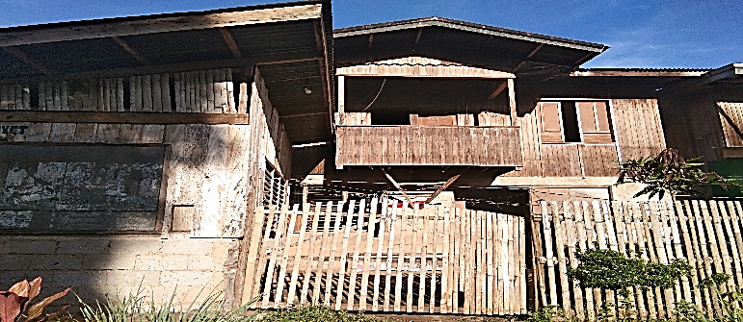

|  |  |  |
| --- | --- | --- |
| Name | Date of Birth | Age |
| Wahing, Cadelario Canete | 2/2/1935 | 84(S) |
| Wahing, Prudencia Tano | 2/21/1934 | 85(S) |
| Wahing, Julieto Tano | 6/7/1980 | 39 |
| Wahing Lolita Villamor |  |  |
| Wahing Josh Esekiel | 10/20/2015 | 4 |
|  | 4ps Member | House Material |
| No | Wood |
| Water Source | Type of Toilet |
| Pipe | Water Sealed |

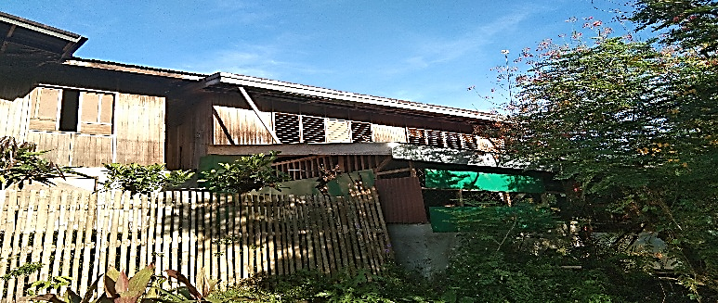

|  |  |  |
| --- | --- | --- |
| Name | Date of Birth | Age |
| Magallanes, Eduardo Balendres | 9/15/1957 | 62(S) |
| Magallanes, Porita Fuentes | 1/14/1950 | 69(S) |
| Magallanes, Genie Fuentes | 3/23/1998 | 21 |
|  | 4ps Member | House Material |
| No | Semi-Concrete |
| Water Source | Type of Toilet |
| Pipe | Water Sealed |

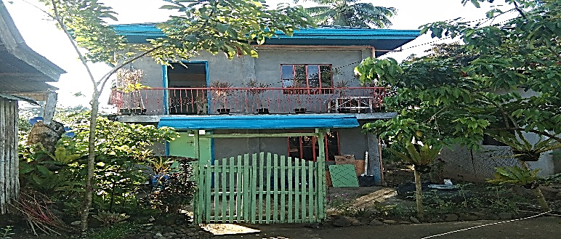

|  |  |  |
| --- | --- | --- |
| Name | Date of Birth | Age |
| Villarido, Agripino Epanto | 11/9/1964 | 55 |
| Villarido, Alejandra Gra-as | 2/27/1974 | 45 |
| Villarido, Messael Ave Gra-as | 9/2/1999 | 20 |
| Villarido, Allel Gra-as | 6/29/2002 | 17 |
| Villarido, Angel Gra –as | 8/9/2004 | 15 |
| Ermac Fermen Leyson | 7/11/1986 | 51 |
| Ermac,Esidora Meyor | 4/9/1942 | 71(S) |
|  | 4ps Member | House Material |
| No | Concrete |
| Water Source | Type of Toilet |
| Pipe | Water Sealed |

|  |  |  |
| --- | --- | --- |
| Name | Date of Birth | Age |
| Lamparas, Randy Restificar | 4/19/1972 | 47 |
| C:\Users\admin\Documents\PONGASI\IMG_20191124_064404.jpg | 4ps Member | House Material |
| No | Concrete |
| Water Source | Type of Toilet |
| Pipe | Water Sealed |

|  |  |  |
| --- | --- | --- |
| Name | Date of Birth | Age |
| Pongasi, Robert Abubo Sr. | 1/29/1966 | 53 |
| Pongasi, Mercedita Albios | 9/5/1968 | 51 |
| Pongasi, Robert Albios Jr. | 3/19/1998 | 21 |
| Pongasi, Romer Albios | 10/21/1996 | 23 |
| Pongasi, Maryl Albios | 3/28/2011 | 8 |
| Pongasi, Ruth Albios | 12/23/1993 | 26 |
| Pongasi,Reuben Albios | 3/12/2015 | 4 |
| C:\Users\admin\Documents\PONGASI\IMG_20191124_064333 - Copy.jpg | 4ps Member | House Material |
| Yes | Wood |
| Water Source | Type of Toilet |
| Pipe | Water Sealed |

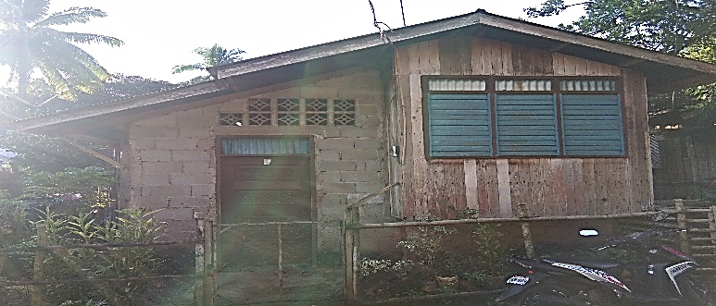

|  |  |  |
| --- | --- | --- |
| Name | Date of Birth | Age |
| Garay, Nestor Gallo | 7/20/1967 | 52 |
| Garay, Jenery Villamor | 11/8/1991 | 28 |
|  | 4ps Member | House Material |
| No | Semi-Concrete |
| Water Source | Type of Toilet |
| Pipe | Water Sealed |

|  |  |  |
| --- | --- | --- |
| Name | Date of Birth | Age |
| Argallon, Fernando Domdom Sr. | 7/24/1951 | 68(S) |
| Argallon, Luzviminda Soliano | 11/26/1957 | 62(S) |
| Argallon, Mary Ann Paler | 3/30/1980 | 39 |
| Argallon, Fernando Jr. | 12/24/1993 | 26 |
|  | 4ps Member | House Material |
| No | Wood |
| Water Source | Type of Toilet |
| Pipe | Water Sealed |

|  |  |  |
| --- | --- | --- |
| Name | Date of Birth | Age |
| Cobrado, Narcisa Albios | 7/6/1956 | 63 (S) |
| Cobrado, Jenerose Albios | 3/22/1982 | 37 |
| Cobrado, Jay-Ann Albios | 2/7/1998 | 21 |
| Cambe, Ronielen Cambe | 11/12/1988 | 31 |
| Cambe, Jazzper Jhon | 10/18/2009 | 10 |
| Cambe, Samantha Nicole | 7/28/2011 | 8 |
| C:\Users\admin\Documents\PONGASI\IMG_20191124_070036 - Copy.jpg | 4ps Member | House Material |
| No | Concrete |
| Water Source | Type of Toilet |
| Pipe | Water Sealed |

|  |  |  |
| --- | --- | --- |
| Name | Date of Birth | Age |
| Cerna, Jenefer Pamplona | 1/15/1970 | 49 |
| Cerna, Cherry Joy Pamplona | 1/27/1995 | 24 |
| Cerna, Aljhon Paul Pamplona | 6/12/1992 | 27 |
| Pamplona, Danaya Grace Albios | 10/7/2005 | 14 |
|  | 4ps Member | House Material |
| No | Concrete |
| Water Source | Type of Toilet |
| Pipe | Water Sealed |

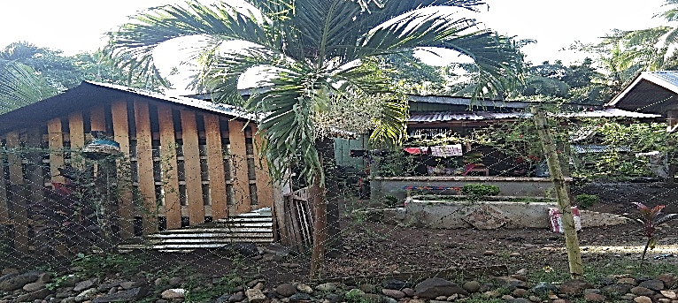

|  |  |  |
| --- | --- | --- |
| Name | Date of Birth | Age |
| Talan, Julie Pamplona | 4/30/1964 | 55 |
| Talan, Jay-R Pamplona |  |  |
| Lomocso, Cecile Pamplona | 3/9/1987 | 32 |
| Lomocso, Herschel Jia Talan | 1/11/2012 | 7 |
|  | 4ps Member | House Material |
| No | Wood |
| Water Source | Type of Toilet |
| Pipe | Water Sealed |

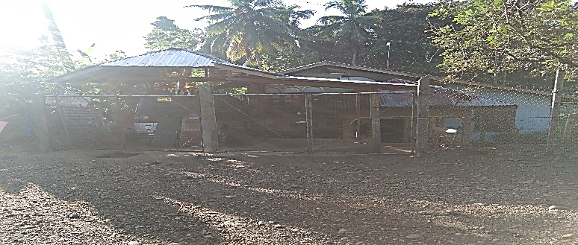

|  |  |  |
| --- | --- | --- |
| Name | Date of Birth | Age |
| Benolirao, Reynaldo Balnig Sr. | 11/25/1960 | 59 |
| Benolirao, Elma Dela Vega | 8/16/1965 | 54 |
| Benolirao, Elfie Dela Vega | 3/31/1988 | 31 |
| Benorilao, Reynaldo Dela Vega Jr. | 6/19/1985 | 34 |
| Benoliarao, Cecilia Marinduque | 2/6/1986 | 33 |
| Benolirao, John Cristoffe Marinduque | 7/18/2011 | 8 |
| Dela Vega, JunjieBinondo | 6/17/1995 | 24 |
|  | 4ps Member | House Material |
| No | Concrete |
| Water Source | Type of Toilet |
| Pipe | Water Sealed |

|  |  |  |
| --- | --- | --- |
| Name | Date of Birth | Age |
| Tubo, Roel Bertulfo | 7/16/1984 | 35 |
| Tubo, Mercy Jean Pondoc | 6/25/1991 | 28 |
| Tubo, Rhean Jean Pondoc | 11/8/2008 | 11 |
| Tubo, Risha Jamaica Pondoc | 1/23/2011 | 8 |
| Tubo, Rylee Jasmine Pondoc | 1/19/2018 | 1 |
| C:\Users\admin\Documents\PONGASI\IMG_20191124_070853 - Copy.jpg | 4ps Member | House Material |
| No | Wood |
| Water Source | Type of Toilet |
| Pipe | Water Sealed |

|  |  |  |
| --- | --- | --- |
| Name | Date of Birth | Age |
| Bertulfo, Vincent Ybanez Sr. | 8/27/1959 | 60(S) |
| Bertulfo, Linda Aya-ay | 3/1/1964 | 55 |
| Bertulfo, Riza Aya-ay | 7/1/1990 | 29 |
| Bertulfo, Vicente Aya-ay Jr. | 6/23/1995 | 24 |
| Bertulfo, Raymond Aya-ay | 12/6/2005 | 14 |
| Bertulfo, Reyna Cris Aya-ay | 4/5/2008 | 11 |
| Bertulfo, Remegio Aya-ay | 8/23/1985 | 34 |
| Bertulfo, Kyla Rose Asoy | 3/18/2010 | 9 |
| Bertulfo, Catherie Asoy | 10/23/2012 | 7 |
| C:\Users\admin\Documents\PONGASI\IMG_20191124_070335 - Copy.jpg | 4ps Member | House Material |
| Yes | wood |
| Water Source | Type of Toilet |
| Pipe | Water Sealed |

|  |  |  |
| --- | --- | --- |
| Name | Date of Birth | Age |
| Tubo, Junie Bertulfo | 6/26/1992 | 27 |
| Tubo, Maricel Balili | 7/12/1992 | 27 |
| Tubo, Jessel May Balili | 6/25/2012 | 7 |
| Tubo, Juniecel Balili | 7/30/2014 | 5 |
|  |  |  |
|  | 4ps Member | House Material |
| Yes | Wood |
| Water Source | Type of Toilet |
| Pipe | Water Sealed |

|  |  |  |
| --- | --- | --- |
| Name | Date of Birth | Age |
| Tubo, Susan Bertulfo | 8/26/1964 | 55 |
| Tubo, Raul Bertulfo | 1/2/1986 | 33 |
| Tubo, Ramil Bertulfo | 1/10/1994 | 25 |
| Tubo, Carol Ann Masayon | 6/3/2012 | 6 |
|  |  |  |
|  | 4ps Member | House Material |
| Yes | Wood |
| Water Source | Type of Toilet |
| Pipe | Water Sealed |

|  |  |  |
| --- | --- | --- |
| Name | Date of Birth | Age |
| Cocamas, Leonilo Pilapil | 12/8/1966 | 53 |
| Cocamas, Maria Lahoy | 5/31/1969 | 50 |
| Cocamas, Kent Leo Lahoy | 3/15/2007 | 12 |
| Cocamas, Cathlyn Bea | 3/26/2006 | 13 |
| C:\Users\admin\Documents\PONGASI\IMG_20191124_070709.jpg | 4ps Member | House Material |
| Yes | Wood |
| Water Source | Type of Toilet |
| Pipe | Water Sealed |

|  |  |  |
| --- | --- | --- |
| Name | Date of Birth | Age |
| Cocamas, Dindo Lahoy | 2/7/1996 | 23 |
| Cocamas, Fe Montanez | 5/21/1996 | 23 |
| Cocamas, Christine Mae Montanez | 11/23/2015 | 4 |
|  |  |  |
|  |  |  |
| C:\Users\admin\Documents\PONGASI\IMG_20191124_070635.jpg | 4ps Member | House Material |
| Yes | Wood |
| Water Source | Type of Toilet |
| Pipe | Water Sealed |

|  |  |  |
| --- | --- | --- |
| Name | Date of Birth | Age |
| Bertulfo, Renato Aya-ay | 10/5/1985 | 34 |
| Bertulfo, Jovina Buhisan | 11/29/1989 | 30 |
| Bertulfo, Alexis Buhisan | 5/18/2018 | 1 |
|  |  |  |
|  |  |  |
| C:\Users\admin\Documents\PONGASI\IMG_20191124_070604.jpg | 4ps Member | House Material |
| Yes | Concrete |
| Water Source | Type of Toilet |
| Pipe | Water Sealed |

|  |  |  |
| --- | --- | --- |
| Name | Date of Birth | Age |
| Arabis, Ginevib Magallanes | 6/16/1988 | 31 |
| Arabis, Abelia Dorimon | 5/9/1982 | 37 |
| Arabis, Gabriel Enigo | 8/15/2011 | 8 |
|  | 4ps Member | House Material |
| Yes | Concrete |
| Water Source | Type of Toilet |
| Pipe | Water Sealed |

|  |  |  |
| --- | --- | --- |
| Name | Date of Birth | Age |
| Rondina, Roberto Ybanez | 1/1/1971 | 48 |
| Rondina, Dolcisimo Ybanez | 2/24/1981 | 38 |
|  | 4ps Member | House Material |
| No | Concrete |
| Water Source | Type of Toilet |
| Pipe | Water Sealed |

|  |  |  |
| --- | --- | --- |
| Name | Date of Birth | Age |
| Damayan, Joel Bertulfo | 11/8/1974 | 45 |
| Damayan, Loueivel Cumawas | 4/19/1977 | 42 |
| Damayan, Markjoy Cumawas | 11/11/1997 | 22 |
| Damayan, Roselyn Cabusao |  |  |
| Damayan, Mark Einstein Cabusao | 7/23/2017 | 2 |
|  | /200  4ps Member | House Material |
| No | Concrete |
| Water Source | Type of Toilet |
| Pipe | Water Sealed |

|  |  |  |
| --- | --- | --- |
| Name | Date of Birth | Age |
| Damayan, Arnold Bertulfo | 2/10/1973 | 46 |
| Damayan, Jenelyn Ojas | 1/14/1983 | 36 |
| Damayan, Gleen Stephen Ojas | 10/18/2003 | 16 |
| Damayan, Arcelyn Ojas | 11/1/2005 | 14 |
| Damayan, Kristine Jean Ojas | 6/3/2008 | 11 |
|  | 4ps Member | House Material |
| Yes | Concrete |
| Water Source | Type of Toilet |
| Pipe | Water Sealed |

|  |  |  |
| --- | --- | --- |
| Name | Date of Birth | Age |
| Aquino, Celestino Tagam Sr. | 5/9/1970 | 49 |
| Aquino, Geneveb Damayan | 4/9/1969 | 59 |
| Aquino, Jessel Damayan | 3/18/2000 | 19 |
| Aquino, Jancel Damayan | 1/11/2007 | 12 |
| Aquino, Celestino Damayan Jr. | 12/12/2005 | 14 |
| Fuentes, Celedonia Egma | 5/10/1949 | 70 (S) |
| Paler, Michelle Egma | 9/13/1987 | 32 |
|  | 4ps Member | House Material |
| Yes | Concrete |
| Water Source | Type of Toilet |
| Pipe | Water Sealed |

|  |  |  |
| --- | --- | --- |
| Name | Date of Birth | Age |
| Gevela, Edgar | 8/21/1961 | 58 |
| Gevela, Meriam Damayan | 6/4/1968 | 51 |
| Gevela, Edgar Brya Damayan | 4/21/1991 | 28 |
| Gevela, Kenneth Bryan | 10/17/2001 | 18 |
|  | 4ps Member | House Material |
| No | Concrete |
| Water Source | Type of Toilet |
| Pipe | Water Sealed |

|  |  |  |
| --- | --- | --- |
| Name | Date of Birth | Age |
| Damayan, Felomino Egma | 11/11/1934 | 85 (S) |
| Damayan, Constancia Pinaso | 1/27/1941 | 78 (S) |
|  | 4ps Member | House Material |
| No | Concrete |
| Water Source | Type of Toilet |
| Pipe | Water Sealed |

|  |  |  |
| --- | --- | --- |
| Name | Date of Birth | Age |
| Combate, Bienvinido | 3/30/1962 | 57 |
| Combate, Elisa Damayan | 7/21/1960 | 59 |
| Combate, Mark Brylle |  |  |
|  | 4ps Member | House Material |
| No | Concrete |
| Water Source | Type of Toilet |
| Pipe | Water Sealed |

|  |  |  |
| --- | --- | --- |
| Name | Date of Birth | 70  Age |
| Fajardo, Sancho | 9/8/1949 | 70 (S) |
| Fajardo, Ludivina Damayan | 9/8/1957 | 62 (S) |
| Fajardo, Judyza Gabas | 1/19/2006 | 13 |
| Paliquit, Santino Damayan | 12/30/2016 | 3 |
|  | 4ps Member | House Material |
| No | Concrete |
| Water Source | Type of Toilet |
| Pipe | Water Sealed |

|  |  |  |
| --- | --- | --- |
| Name | Date of Birth | Age |
| Dano, Mervin |  |  |
| Dano, Juvy Pajardo |  |  |
|  | 4ps Member | House Material |
| No | Concrete |
| Water Source | Type of Toilet |
| Pipe | Water Sealed |

|  |  |  |
| --- | --- | --- |
| Name | Date of Birth | Age |
| Damayan, Felecito Bertulfo | 8/2/1985 | 34 |
| Damayan, Josephine Lopez | 5/7/1992 | 27 |
| Damayn, Divine Grace Lopez | 11/11/2010 | 9 |
| Damayan, Joshua | 9/6/2012 | 7 |
|  | 4ps Member | House Material |
| No | Concrete |
| Water Source | Type of Toilet |
| Pipe | Water Sealed |

|  |  |  |
| --- | --- | --- |
| Name | Date of Birth | Age |
| Dorimon, Julieto Perater | 1/1/1981 | 38 |
| Dorimon, Jimmy Perater | 3/10/1993 | 26 |
|  | 4ps Member | House Material |
| No | Concrete |
| Water Source | Type of Toilet |
| Pipe | Water Sealed |

|  |  |  |
| --- | --- | --- |
| Name | Date of Birth | Age |
| Pasgala, Jonalyn Dorimon | 6/13/1985 | 34 |
| Pasgala, Kenneth Dorimon | 12/20/2001 | 18 |
| Pasgala, April Joy Dorimon | 4/27/2004 | 15 |
| Pasgala,Lovely Dorimon | 9/13/2006 | 13 |
| Pasgala, Lovely Jane Dorimon | 8/25/2009 | 10 |
| Pasgala, Keutilyn Dorimon | 8/19/2011 | 8 |
| Pasgala, Jenelyn Dorimon | 5/23/2014 | 5 |
| Pasgala, Solidad Bonghas | 5/9/1947 | 72(S) |
| C:\Users\admin\Documents\PONGASI\IMG_20191124_071214 - Copy.jpg | 4ps Member | House Material |
| Yes | Concrete |
| Water Source | Type of Toilet |
| Pipe | Water Sealed |

|  |  |  |
| --- | --- | --- |
| Name | Date of Birth | Age |
| Bantuan, Cok Manabtab | 12/15/1960 | 59 |
| Bantuan, Gina Pongasi | 9/28/1978 | 41 |
| Bantuan,Magid Pongasi | 12/12/2001 | 18 |
| Bantuan, Anera Pongasi | 9/4/2005 | 14 |
| Bantuan, Aliza Pongasi | 3/18/2011 | 8 |
| C:\Users\admin\Documents\PONGASI\IMG_20191124_071138 - Copy.jpgBantuan, Norhaina Pongasi | 7/8/2017 | 2 |
|  | 4ps Member | House Material |
| No | Concrete |
| Water Source | Type of Toilet |
| Pipe | Water Sealed |

|  |  |  |
| --- | --- | --- |
| Name | Date of Birth | Age |
| Edao, Kemjie Uy | 12/12/1974 | 45 |
| Edao, Rosely Campomanes | 10/1/1975 | 44 |
| Edao, Krezylle Campomanes | 8/26/2008 | 11 |
| C:\Users\admin\Documents\PONGASI\IMG_20191124_070952 - Copy.jpg | 4ps Member | House Material |
| No | Concrete |
| Water Source | Type of Toilet |
| Pipe | Water Sealed |

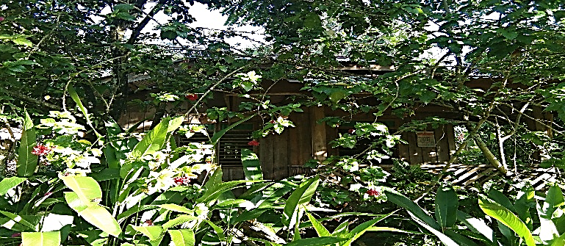

|  |  |  |
| --- | --- | --- |
| Name | Date of Birth | Age |
| Campomanes, Agustin Granada | 8/25/1947 | 72 (S) |
| Campomanes, Beatriz Ermac | 4/5/1957 | 62 (S) |
|  | 4ps Member | House Material |
| No | Concrete |
| Water Source | Type of Toilet |
| Pipe | Water Sealed |

|  |  |  |
| --- | --- | --- |
| Name | Date of Birth | Age |
| Ermac, Julieto Masayon Sr. | 1/29/1972 | 47 |
| Ermac, Queny Apale | 4/8/1980 | 39 |
| Ermac, Queny Joy Apale | 5/21/2001 | 18 |
| Ermac,Jorge Jay Apale | 6/15/2004 | 15 |
| Ermac, Julieto Apale Jr. | 9/12/2005 | 14 |
| Ermac, Jack Apale | 9/12/2005 | 14 |
| Ermac, Jay- R Apale | 10/13/2006 | 13 |
| Ermac, Christie Joy Apale | 7/29/2011 | 8 |
| Ermac, Grace Apale | 8/15/2013 | 6 |
| Ermac, Princess Joy Apale | 8/17/2015 | 4 |
| C:\Users\admin\Documents\PONGASI\IMG_20191124_071514 - Copy.jpg | 4ps Member | House Material |
| Yes | Wood |
| Water Source | Type of Toilet |
| Pipe | Water Sealed |

|  |  |  |
| --- | --- | --- |
| L  Name | Date of Birth | Age |
| Lagamon, Eduardo Rendon | 6/10/1959 | 60 (S) |
| Lagamon, Luzminda De Loyola | 1/17/1966 | 53 |
| De Loyola, Eustaquio Redoblado |  |  |
| De Loyola, Leodegaria Gonzaga |  |  |
| C:\Users\admin\Documents\PONGASI\IMG_20191124_071636.jpg | 4ps Member | House Material |
| No | Semi-Concrete |
| Water Source | Type of Toilet |
| Pipe | Water Sealed |

|  |  |  |
| --- | --- | --- |
| Name | Date of Birth | Age |
| Husain, Jalaica Cali | 4/13/ 1992 | 27 |
| Husain, Jiaber Cali | 10/20/2013 | 6 |
| Husain, Johaina Cali | 4/12/2017 | 2 |
| C:\Users\admin\Documents\PONGASI\IMG_20191124_071738.jpg | 4ps Member | House Material |
| Yes | Concrete |
| Water Source | Type of Toilet |
| Pipe | Water Sealed |

|  |  |  |
| --- | --- | --- |
| Name | Date of Birth | Age |
| Culamis, Jocelyn Olita | 5/11/1975 | 44 |
| Culamis, Elmer Canete | 4/6/2000 | 19 |
| Culamis, Ernesto Canete | 10/10/2009 | 10 |
| Culamis, Juvy Canete | 4/8/1996 | 23 |
| Culamis, Reymark Canete | 8/3/2014 | 5 |
| Culamis, Rhea Jean Canete | 7/25/2018 | 1 |
|  | 4ps Member | House Material |
| Yes | Concrete |
| Water Source | Type of Toilet |
| Pipe | Water Sealed |

|  |  |  |
| --- | --- | --- |
| Name | Date of Birth | Age |
| Canete, Violeta Olita | 4/4/1957 |  |
| Canete, Jonaveth Olita | 10/23/1995 | 24 |
| Canete, Jenny OLita | 3/24/1997 | 22 |
| Canete, Merry Jane Ausan | 12/8/2003 | 16 |
| Canete, Rogela Ausan | 8/27/2005 | 14 |
| Canete, Rocel Ausan | 2/20/2008 | 11 |
| C:\Users\admin\Documents\PONGASI\IMG_20191124_071801 - Copy.jpg | 4ps Member | House Material |
| No | Concrete |
| Water Source | Type of Toilet |
| Pipe | Water Sealed |

|  |  |  |
| --- | --- | --- |
| Name | Date of Birth | Age |
| Tangan, Felix Rato | 9/10/1969 | 50 |
| Tangan, Christine Garcia | 10/20/1965 | 54 |
| Tangan, Kent Joshua Garcia | 11/18/1995 | 24 |
| Tangan, Kathreen Joyce Garcia | 6/3/2000 | 19 |
| C:\Users\admin\Documents\PONGASI\IMG_20191124_071920 - Copy.jpg | 4ps Member | House Material |
| No | Concrete |
| Water Source | Type of Toilet |
| Pipe | Water Sealed |

|  |  |  |
| --- | --- | --- |
| Name | Date of Birth | Age |
| Gementiza, Jay Pinonggan | 12/11/1980 | 39 |
|  | 4ps Member | House Material |
| No | Concrete |
| Water Source | Type of Toilet |
| Pipe | Water Sealed |

|  |  |  |
| --- | --- | --- |
| Name | Date of Birth | Age |
| Dela Torre, Renato |  |  |
| Dela Torre, Emma |  |  |
|  |  |  |
|  |  |  |
|  |  |  |
|  | 4ps Member | House Material |
| No | Concrete |
| Water Source | Type of Toilet |
| Pipe | Water Sealed |

|  |  |  |
| --- | --- | --- |
| Name | Date of Birth | Age |
| Alo, Nestor Bama | 2/26/1962 | 57 |
| Alo, Tita Baugbog | 2/6/1960 | 59 |
| Alo, Genesis Baugbog | 6/7/2005 | 14 |
|  |  |  |
|  |  |  |
|  | 4ps Member | House Material |
| No | Concrete |
| Water Source | Type of Toilet |
| Pipe | Water Sealed |